**Ozark Season 4: Release Date and other details!** 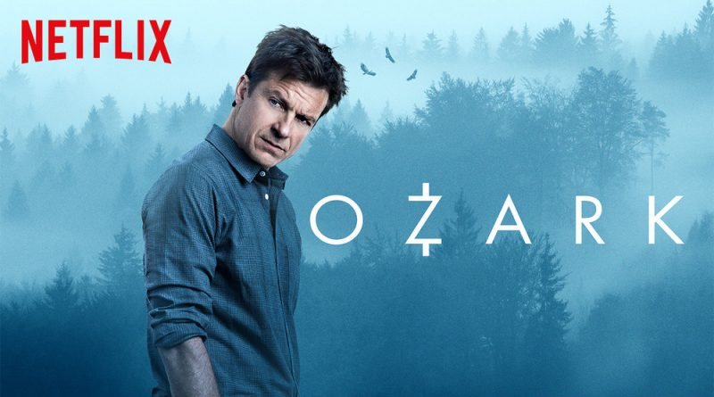

**Ozark**, an American crime drama *television series*, streaming on **Netflix**, was designed by Bill Dubuque and Mark Williams and produced by Media Rights capital. It's recognized as the *series* with the highest no. of awards and nominations reception. *Season 1* of Ozark was premiered on July 21, 2017, *season 2* on August 31, 2018, and then *season 3* was brought to the viewer's screen on March 27, 2020. From that time only its fans are eagerly waiting to hear its renewal news for *season 4*. So, let's catch up on what we have for you.

**Ozark Season 4: Release Date**

**Ozark** was renewed for **season 4** in June 2020. It was announced that it will comprise 14 episodes divided into two parts and it'll be the last season of this *series*. While all the previous *seasons* consisted of 10 episodes each. *Season 4* of *Ozark* is heard to be filmed in Atlanta, Georgia. Its first seven episodes are anticipated to be released by mid of 2021 while the second half is expected to be streamed by 2022. The filming process for the series began on November 9, 2020, and each episode of the series takes approximately 11 days to film. So, *season 4* is likely to be on the viewers' screen by mid of 2021.

**Ozark Season 4: Probable Cast**

Since no information about the cast has been publicized yet so we can expect the main characters to be the same, there may be few more characters who'll join the team but mostly the protagonists are likely to recur their role. Some of them are:

Jason Bateman being **Martin Byrde**, Wendy's spouse and Jonah and Charlotte's father

Laura Linney being **Wendy Byrde**, Marty's spouse and Jonah and Charlotte's father

Sofia Hublitz being Charlotte Byrde, Wendy and Marty's teen daughter

Skylar Gaertner being Jonah Byrde, Wendy and Marty's teen son

Julia Garner being Ruth Langmore

Jordano Spiro being Rachel Garrison, Owner of the Blue Cat bar and hotel, and Marty's business ally

Jason Butler Harner being Roy Petty, an FBI agent who investigates Marty in season 1 and 2

Esai Morales being Camino Del Rio, a lieutenant

Peter Mullan being Jacob Snell

Lisa Emery being Darlene Snell, Jacob's spouse

Charlie Tahan being Wyatt Langmore

Janet McTeer being Helen Pierce

Tom Pelphrey being Ben Davis

Jessica Frances Dukes being Maya Miller, an FBI forensic accountant

Felix Solis being Omar Navarro, leader of the Mexican drug

Damian Young being Jim Rattelsdorf, the Byrdes partner

Adam Rothenberg being Mel Sattem, cop turned personal investigator

Alfonso Herrera being Javi Elizonndro, a lieutenant

and others. 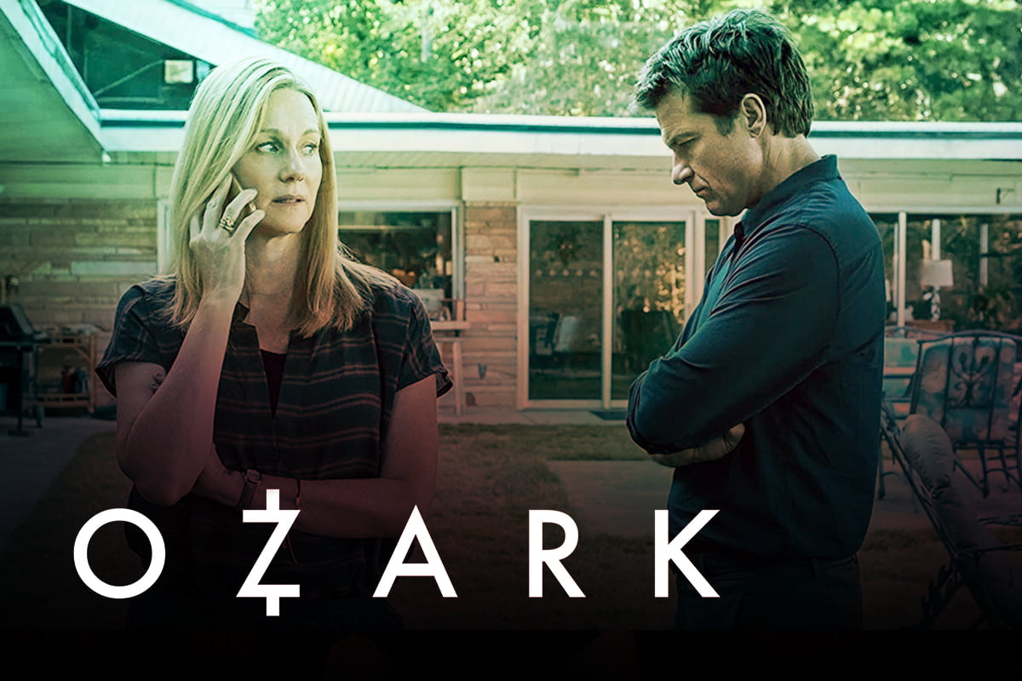

**Ozark Season 4: Expected Plot**

The *series* completely revolves around the criminal act of fraud for money. *Marty Byrde* is involved in money laundering but when the plan for a Mexican drug cartel gets spoiled, he plans another bigger money laundering scheme in the Lake of the Ozarks province of Central Missouri. But all of a sudden, he needs to shift to Osage Beach, a remote location from the Chicago province of Naperville with his family. There he gets involved in bigger crimes with the local culprits, involving the Snell and Langmore families, and subsequently, he gets mess up with Kansas City Mafia. So, we can expect the storyline to take up the turn showing what *Byrdes* can do to take immense advantage of the mistakes he committed. *Season 4* will completely be reflecting the characters' actions who'll be trying to correct the mistakes they did in the previous seasons and try to stabilize their own life.

**Ozark Season 4: Trailer**

As of now the **trailer** for season 4 has not been released, so till that time you can enjoy the *trailer* of *season 3*😊

https://www.youtube.com/watch?v=oNDTOy5bU_4